**TITLE**

**BRIDGE OVER – MEGA PROJECT**

**ITS POSSIBLE OR NOT?????**

**Author**

**Susan Timsina**

**4th year student**

**Pulchowk Campus**

**Abstract**

Combination of bridge and flyover which we termed "BRIDGE OVER" is the project that we thought to be one of the national mega project one day. As our country is country with geographic diversity, Our upper regions are hilly and mountaineous region with small to high hills and mountains where development is very difficult due to lack of transportation means and due to dangerous small roads accessing that place on hills. As We see and listen various accidents in hilly region due to condition of roads (i.e narrow and not properly graveled) which is risking many individuals life. Due to lack of place in hill for expansion roads are narrow thus by considering these difficulty in construction of roads in hilly area by cutting hills causing risk of landslide and increase in traffic problems in hilly roads (considering Thankot- Naubise road). We thought and learned of an idea in order to minimize risks of landslide and proper flow of traffic in that region. In this project we thought of an idea to built bridge over respect to curvature of hills through which it pass by providing the support ( i.e column to support the beam whose height is maintained per terrain slope). We believed that this project will definitely be the best project to develop expressway reduce the meandering roads in hill to straight , reduce distance of travel, reduce traffic problems that we face during travel to our village and so on.

Our "Bridge Over - Mega Project" is project that we dreamed off that may come into practice in near future in the country. We basically consider Naghdunga Naubise road area (the entrance for both eastern and western Nepal) which usually faces high traffic problems & various other problems caused by landslide during rainy seasons. We usually are also the victim of the bad condition of the road which are usually being faced during the transportation done for various purpose. As we all know that the tunnel fast back is also under construction in that area from Chandragiri ( Naghdhunga Tunnel ,East portal) to Naghdhunga Tunnel West portal, which we thought to be our start point of this project. Continuing the tunnel fast track, we dreamt of the “bridge over” as a part of that expressway that we hoped to reduce the passage of road transport from about 24km to 5 km saving most of the travelling time time. We from this project hope to standardize the level of transportation in country.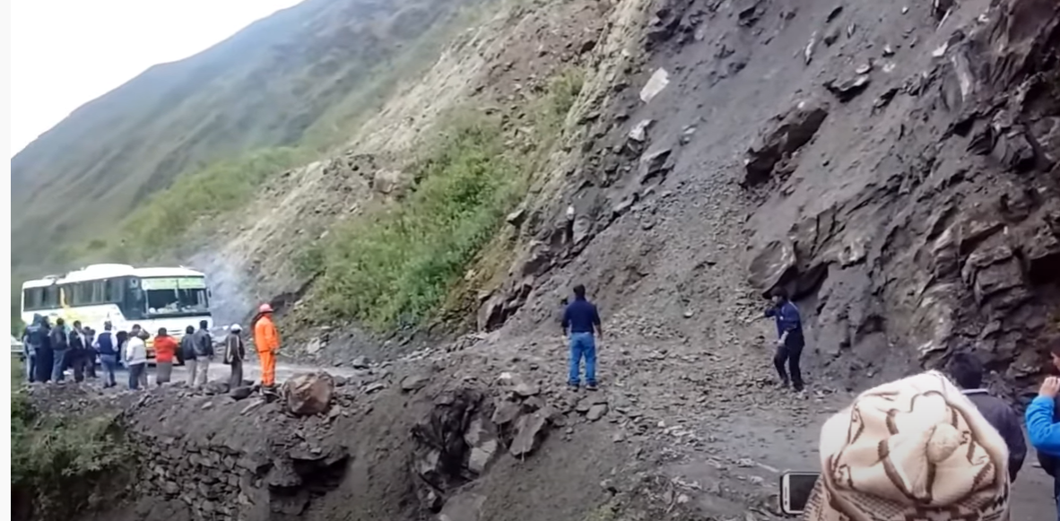

**DIFFICULTY IN HILLY ROADS**

**Objectives**

1. To construct the first over Bridge Over in County.

2. To standardize level of transportation in Country.

3. To solve the traffic problem faced in that area.

4. To reduce the damage caused by landslide in transportation sector.

5. Reduction of travel distance.