[1]

Abstract

Insert your abstract here. (max. 250 words)

*Keywords*: Type your keywords here (3-5), separated by semicolons;

1. Introduction

The introduction should be prepared in paragraphs of 10 font with a spacing of exactly 12 pt. The introduction should have an adequate link with relevant recent literature.

Throughout the paper, paragraphs should continue with second and subsequent lines indented. Paragraphs are only separated by headings, subheadings, tables, images and equations.

1. Paper Format

Files must be prepared in a single column format in MS Word using this template file. Please do not alter the formatting set up in this template document.

The total length of the paper should not exceed a maximum length of 12 pages, including figures, tables, references, and appendices.

1. **Structure**

The manuscript should be prepared following: Title, Authors, Affiliations, Abstract, Keywords, Main text (introduction and other sections including figures and tables), Acknowledgements (if any), Appendix (if any) and References. Provide acknowledgements in a separate section at the end of the article and do not include them on the title page.

Bulleted lists may be included and should look like this:

* First point
* Second point
* And so on

1. **Section headings**

Section headings should be left justified, bold, with the first letters capitalized and numbered consecutively, starting with the Introduction. All headings should have a minimum of three text lines after them.

1. Subheadings

Subsection headings should be typed in a bold typeface with the first letter of the first word capitalized and the remaining words in lower-case italic letters, numbered ***1.1***, ***1.2***, etc., and left justified. Subsections can be further subdivided using three-level numbers *1.1.1*, *1.1.2* etc., left justified headings with the first word capitalized and the remaining words in lower-case italic letters.

1. **Tables**

All tables should be numbered with Arabic numerals. Every table should have a caption. Headings should be placed centered above tables in 8 pt. font. Only horizontal lines should be used to distinguish the column headings from the body of the table and immediately above and below the table. Tables must be embedded into the text and not supplied separately. Below is an example that the authors may find useful.

Table 1. An example of a table

|  |  |  |
| --- | --- | --- |
| Column heading | Column A | Column B |
| Entry 1 | 1 | 2 |
| Entry 2 | 3 | 4 |
| Entry 3 | 5 | 6 |

1. **Figures**

All figures should be numbered with Arabic numerals. Every figure should have a caption. All photographs, schemas, graphs and diagrams are to be referred to as figures. Figures should be good quality scans or true electronic output and must be embedded into the text and not supplied separately. The figure number and caption should be placed centered below the illustration in 8 pt. font.

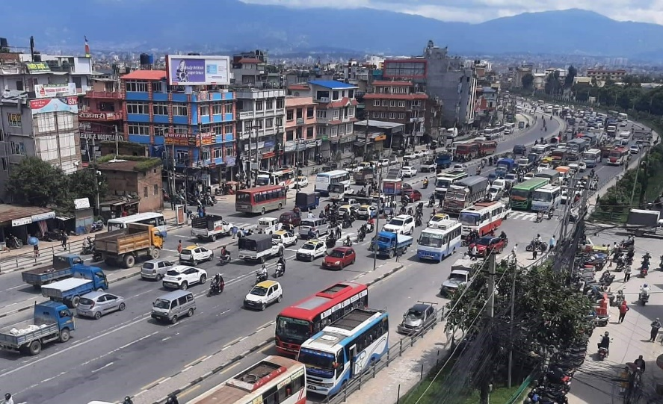

Figure 1. An example of figure

1. **Equations**

Equations and formulae should be typed using the equation editor in MS-Word, and numbered consecutively with the right justified Arabic numerals in parentheses. “Graphically designed” equations should not be used.

$y=β_{0}+β_{1}x_{1}+β_{2}x_{2}+β_{3}x_{3}+…+β_{n}x_{n}+ℇ$ (1)

Where,

y: Dependent variable

$x_{1}, x_{2}, x_{3},…, x_{n}$: Independent variables

$β_{0},β_{1}, β_{2},β_{3},…, β_{n}$: Regression coefficients

ℇ: Residual error

1. Paper Submission

All full paper files must be submitted in MS-Word format through email to soten.nepal@gmal.com.

1. References

APA style must be used for citing the references. For detail, please refer to <https://apastyle.apa.org/style-grammar-guidelines/references/examples>.

1. Corresponding author. Tel.: +0-000-000-0000

   *E-mail address:* author@institute.xxx